PUR 3100
Social Media Posts
Lydia

Target Audience: Churches and their congregations.

FACEBOOK:

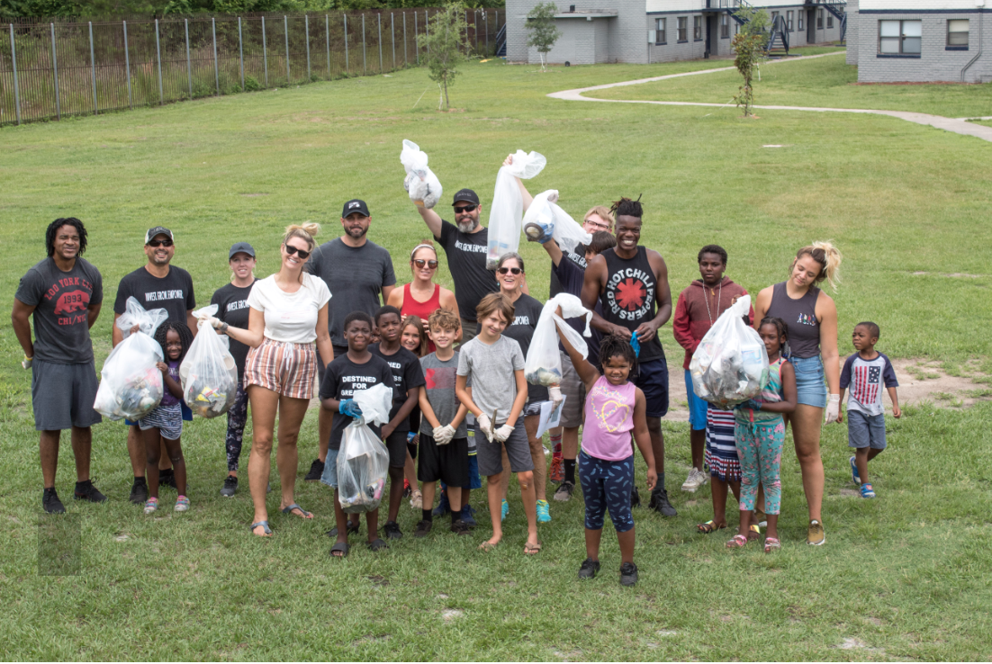
“We have never seen anything like this in the community before. We are used to seeing organizations coming and leaving. No one would stay. That’s what has set Sponsored by GRACE apart, y’all stayed. And y’all care” - Mr. Matthew

Sponsored By GRACE is making a real impact in our community! Now is your time to get involved with this change! If you or a group are interested in volunteering to help make a difference, click below!
SERVE WITH US!

INSTAGRAM: I would also link this post in my Instagram story (I’ve seen this work so well)

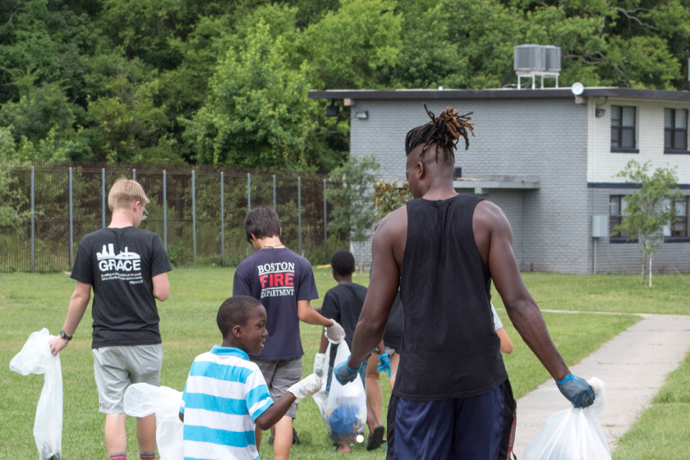
“We have never seen anything like this in the community before. We are used to seeing organizations coming and leaving. No one would stay. That’s what has set Sponsored by GRACE apart, y’all stayed. And y’all care” - Mr. Matthew

@SponsoredbyGRACE is making a real impact in our community! Now is your time to get involved with this change! If you or a group are interested in volunteering to help make a difference, click below!
SERVE WITH US!

#sponsoredbygrace #servejax #impactjax #impactsaturdays #volunteering #bethechangeyouwanttosee #igersjax

*TWITTER ON NEXT PAGE*

TWITTER:

@SponsoredbyGRACE is having an incredible impact in the Jacksonville community. Visit their page SPG TESTIMONIALS to read about change that is happening in our city right now! Don’t waste another minute thinking about it, click the link below to volunteer!
SERVE WITH US! #sponsoredbygrace #impactsaturdays #impactjax

